USER DOCUMENTATION

The following are steps for Windows in command prompt.
First make sure Flask is installed in your main folder path where save the app.py file and the static and templates folder.
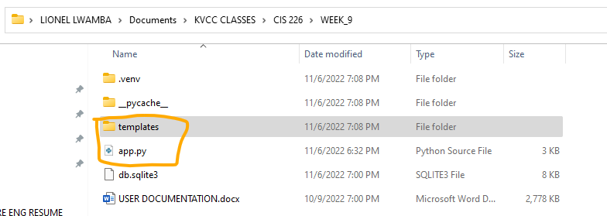
The following screenshots shows the files contained in the statics and templates folders:
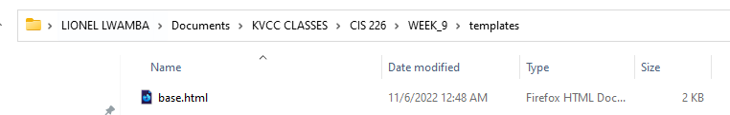

Next go the command prompt and type the following commands in order:
venv\Scripts\activate

set FLASK_APP=app.py

flask run

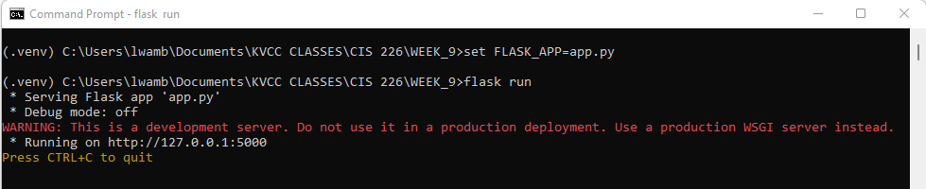

After enter the “flask run” command, the server is now on, and the program can be ran on the browser.

Now go to the browser and go to the following link http://127.0.0.1:5000/ , and the program will start as shown below:

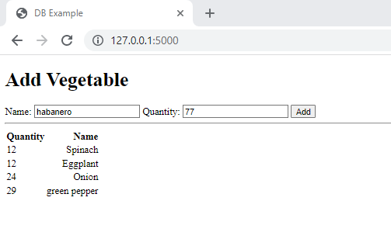
You can enter the vegetable name and quantity, and the quantity and name will show up when you add it as shown above.

DEVELOPMENT CYCLE:
The HTML code defines the user interface for the program. The form elements are used to submit data to the Python program. The Python program uses the flask module to handle the HTTP requests. The program also uses the sqlite3 module to connect to the database. The program uses the cursor object to execute SQL statements.

The program first creates the vegetables table in the database. The program then inserts data into the table. The program then retrieves data from the table. The program then renders the data in the HTML template. The program then displays the data in the browser.

The program is designed to prevent SQL injection. The program only allows data to be inserted into the database. The program allows data to be displayed in the HTML template.

The program is designed to start only when ran. The program is not imported into another program.

